

Regulated Waste eDOCS Upload Guide
How to Save Environmental Regulated Waste Documents through eDOCS Employee Web
3/4/2020
Minnesota Department of Transportation
Office of Administration, Business Integration Section
395 John Ireland Boulevard, MS 635
St. Paul, MN (zip) 55155
MN_DOT_eDOCS
eDOCS Employee Web
Upon request, this material will be made available in an alternative format such as large print, Braille or audio recording

Table of Contents
Regulated Waste eDOCS Upload Guide 1
Table of Contents 2
Logging-into eDOCS Employee Web Upload Screen 2
List of Profile Fields and Descriptions 4
Uploading Regulated Waste Document(s) with Identical Profile Field Values 6
Uploading Regulated Waste Documents with Unique Profile Field Values 8
Summary 10

Important!
What are profile field values? You’ll see this word used a lot in this guide. Profile field data is essentially data about data, or in the case of eDOCS and eDOCS Employee Web, the values people will use to find the documents you save. Think of them like labels. Properly and consistently entering profile field values such as document date, district, or S.P. Number make finding those documents when you need them much easier and more reliable.

Logging-into eDOCS Employee Web Upload Screen

Task Overview
This section will guide you through navigating to eDOCS Employee Web, saving a shortcut for future use, and logging-into the eDOCS Employee Web upload screen.
Important!
You must have an eDOCS account to be able to upload documents using this process. To request an eDOCS user account contact your supervisor and your access authority. Searching and viewing documents does not require an account.

Step-By-step
Step 1: Prepare your Regulated Waste document and save to your drive of choice.
Step 2: Access eDOCS Employee Web via MnDOT’s iHub home page by selecting Documents eDOCS eDOCS Employee Web or just go directly to the URL http://edocs/edigs.
Pro tip!
Create a shortcut to eDOCS Employee Web, http://edocs/edigs, either through a shortcut on your desktop or bookmark it in your favorite web browser. To create a shortcut on your desktop, copy the link, right-mouse click on your desktop and select New Shortcut. Paste the copied link into the location field and select Finish. Right-mouse (click) on that shortcut and rename it to eDOCS Employee Web.
Step 3: On the eDOCS Employee Web home page, select Upload Documents.
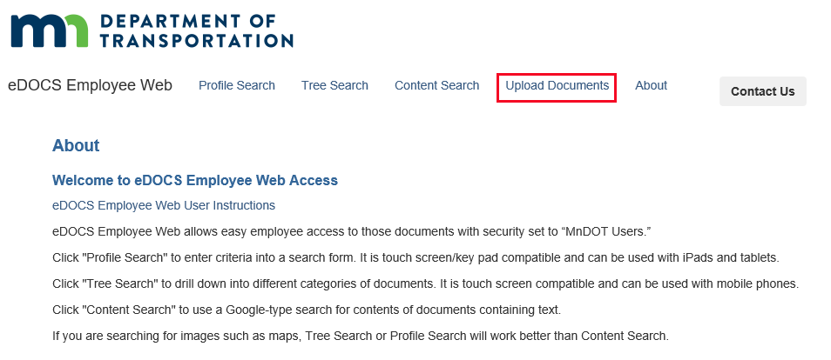
Step 4: Enter the same user name and password you use to log into your computer workstation.
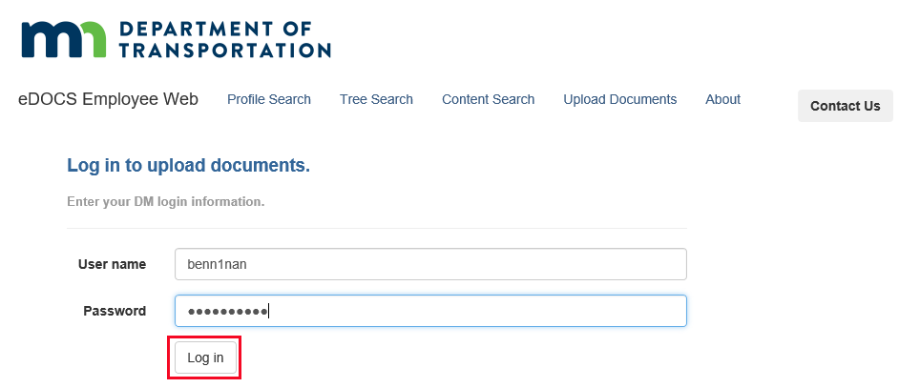

Step 5: Select either the Maintenance or Construction Regulated Waste tab in the left column as appropriate and the upload screen will display.
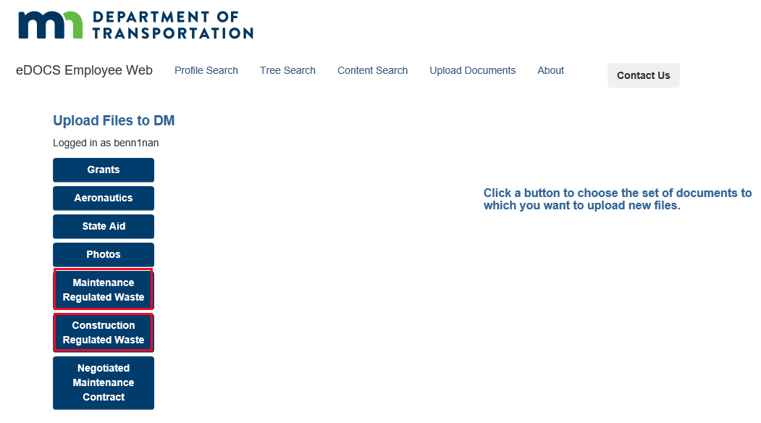
Congratulations! You have successfully navigated to eDOCS Employee Web and logged into the upload forms page.

List of Profile Fields and Descriptions

Maintenance profile fields to fill out
Profile Field | Description
Author | This is the name of the document(s) uploader and should auto-populate.
District | This is the district where the regulated waste was located.
Date of Shipment Offsite | Date regulated waste was shipped offsite. Defaults to today’s date.
Document Date | Date document(s) was/were created. Defaults to today’s date.
Facility | MnDOT facility where the regulated waste was located.
Description | Free form description of the document(s) to be updated.
Keywords | List of keywords describing regulated waste. Can select multiple.
Check Box: Apply these Profile Field Values to All Documents? | Applies entered profile field values to all uploaded documents.

Construction profile fields to fill out
Profile Field | Description
Author | This is the name of the document(s) uploader and should auto-populate.
District | District where the regulated waste was located.
Date of Shipment Offsite | Date regulated waste was shipped offsite. Defaults to today’s date.
Document Date | Date document(s) was/were created. Defaults to today’s date.
Highway | Trunk Highway where the regulated waste was located, if applicable.
Waste Vendor Name (Required) | Name of the vendor who transported the waste.
Bridge # | Bridge ID number where the regulated waste was located, if applicable.
State Project No. | State project where the regulated waste was located, if applicable.
Description | Free form description of the document(s) to be updated.
Keywords | List of keywords describing regulated waste. Can select multiple.
Check Box: Apply these Profile Field Values to All Documents? | Only used if multiple documents are uploaded in one operation

Uploading Regulated Waste Document(s) with Identical Profile Field Values

Overview
In this section, we’ll cover uploading one or more regulated waste documents that will have the same profile field values applied to them. Alternatively, you can upload a batch of documents but apply unique profile field values to each, the process for which is covered in the next section.

Step-By-step
Step 1: Navigate to eDOCS Employee Web and select the Upload Documents screen by following the directions in the previous section and select either the Maintenance Regulate Waste or Construction Regulated Waste form.
Step 2: Ensure the Apply these Profile field Values to All Documents box is checked.
Step 3: Fill-out the profile fields for the form you’ve chosen. Notes, some fields will be pre-populated, but you can still edit them.
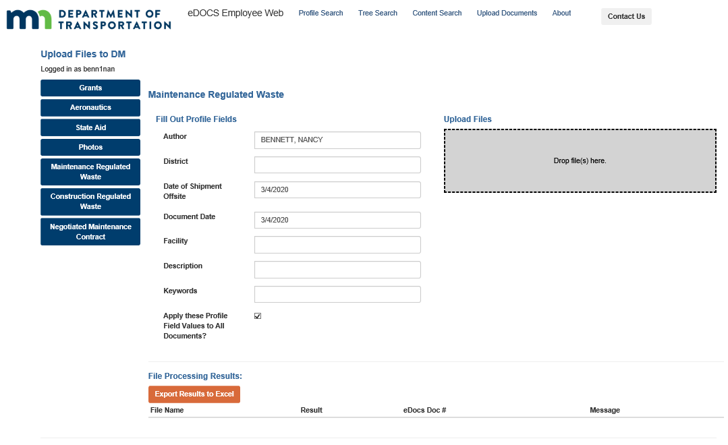
Step 4: Either click in the gray Drop file(s) here box (below Upload Files) and browse to the files you want to upload or click and drag those files into the same gray box.
Important!
If you do not see the gray Drop file(s) here box, it means a required profile field was left blank.
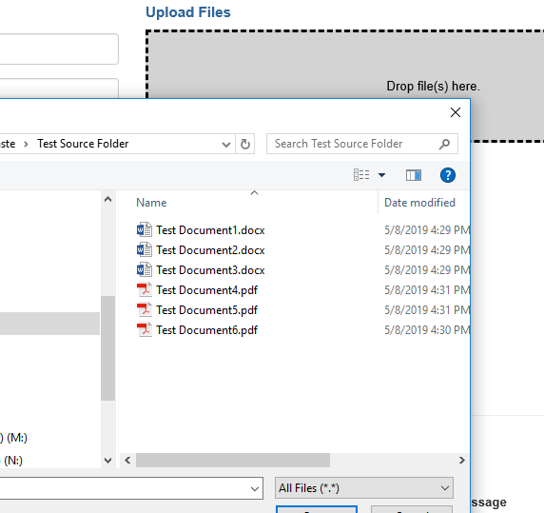
Step 5: Look for a upload confirmation message and a list of uploaded files at the bottom of the screen.
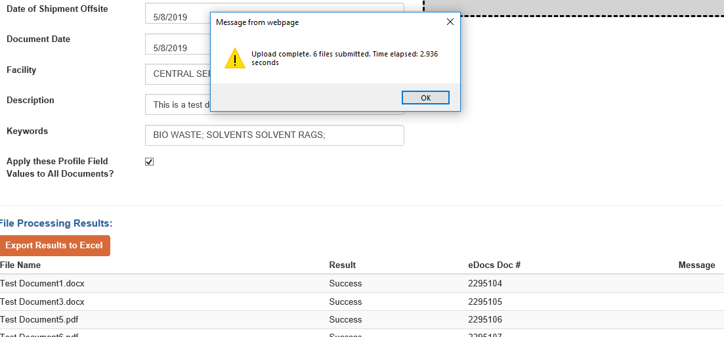
Important!
You cannot change a document’s profile field values using eDOCS Employee Web once has been uploaded. All edits to a document’s profile fields in eDOCS must be made using the desktop eDOCS software.
Congratulations! You have successfully uploaded one or more regulated waste documents with identical profile field values into eDOCS using the eDOCS Employee Web interface. See the next section to learn how to upload one or more regulated waste documents with unique profile field values, or read further to learn how to find documents saved in eDOCS using the eDOCS Employee Web interface.

Uploading Regulated Waste Documents with Unique Profile Field Values

Overview
In this section, we’ll cover uploading one or more regulated waste documents that have unique metadata applied to each of them. The process for uploading documents using either the Maintenance Regulated Waste or the Construction Regulated Waste forms is nearly identical, but the process differs significantly if you want to upload a batch of documents but apply identical metadata to each. Uploading regulated waste documents with identical metadata applied is covered in the Uploading Regulated Waste Documents with Identical Metadata.

Step-By-step
Step 1: Navigate to eDOCS Employee Web and select the Upload Documents screen by following the directions in the previous section and select either the Maintenance Regulate Waste or Construction Regulated Waste form.
Step 2: Ensure the Apply these Profile field Values to All Documents box is unchecked.
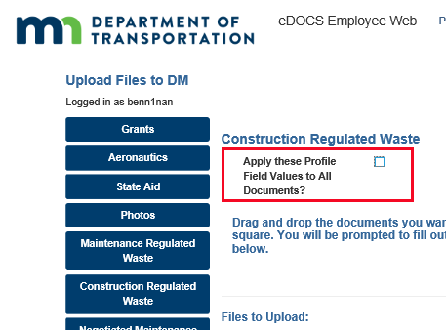
Step 3: Either click in the gray Drop file(s) here box (below Upload Files) and browse to the files you want to upload or click and drag those files into the same gray box.

Step 4: For each file you selected to upload, a row should appear on the screen. Fill-out metadata fields for each file you are uploading. Notes, some fields will be pre-populated, but you can still edit them.
Step 5: When you are finished editing metadata for all the files, click Upload.
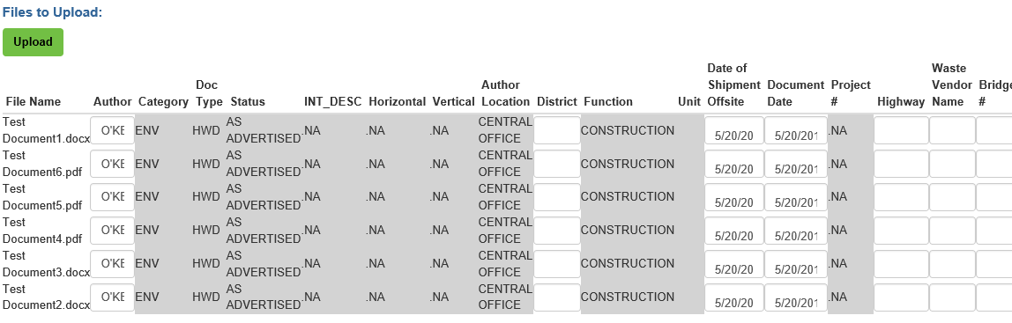
Step 6: A confirmation window will appear confirming the files were uploaded.
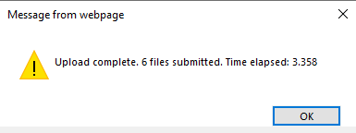
Congratulations! You have successfully uploaded one or more regulated waste documents with unique metadata into eDOCS using the eDOCS Employee Web interface. See the previous section to learn how to upload one or more regulated waste documents with identical metadata, or read further to learn how to find documents saved in eDOCS using the eDOCS Employee Web interface.

Summary
This guide provides instructions for saving regulated waste documents into eDOCS using the eDOCS Employee Web interface. So why use the eDOCS Employee Web interface instead on just using the standard eDOCS software for saving and searching for documents? Why was it developed?
The eDOCS Employee Web interface is optimized to make saving documents into eDOCS faster and profile field data entry more consistent and to reduce the learning curve for finding specific types of documents in eDOCS. The eDOCS Employee Web interface streamlines document saving by prepopulating or providing limited options for profile fields wherever possible, by bypassing the requirement that content creators install the eDOCS desktop software onto their computer in order to save documents to eDOCS, and by providing a mobile-friendly interface for saving and searching for documents stored in eDOCS. In addition, the eDOCS Employee Web interface streamlines document retrieval by providing three intuitive search options tailored to the document type selected: the tree search, the profile search, and the content search.
Note, eDOCS Employee Web cannot do everything that the eDOCS desktop software can do, such as editing profile fields for a document after it has been saved to eDOCS. Power eDOCS users will still want the desktop software available to them, though even they may find the eDOCS Employee Web upload forms to be a convenient way to save batches of documents.

